**Programming Fundamentals-Assignment#02**

**Dr. Sheeraz Arif-Spring-22**

**Given Date-30-12-2024 Submission Deadline-27-01-25**

Note: Write the source programs of the following problems in c/c++ code:

**Question#01**

**12.**Write a program in C++ to calculate the sum of the series (1*1) + (2*2) + (3*3) + (.(n*n).   
Sample Output: (Use While loop)  
Input the value for the nth term: 5  
1*1 = 1   
2*2 = 4   
3*3 = 9   
4*4 = 16  
The sum of the above series is: 30

**Question#2**

A program that takes the input of two numbers from user as a starting and ending then prints all even numbers between them and show the product of all odd numbers. (Use for loop)

**Output:**   
*Enter starting number: 7*

*Enter ending number: 25*

*Even numbers between 7 and 15 are*

*8, 10, 12, 14, 16, 18, 20, 22, 24*

*7*9*11*13*….*

**Question #03**

A program that takes input of integers repeatedly until user enters a zero digit then it prints the number of positive and negative integers.

**Output:**

*Enter a number: 13*

*Enter a number: -21*

*Enter a number: -51*

*Enter a number: -69*

*Enter a number: 22*

*Enter a number: -76*

*Enter a number: -9*

*Enter a number: 0*

*Positive numbers are: 4*

*Negative numbers are: 2*

**(Hint: You can use while loop/do-while with unexpected termination)**

**Question #04**

 Write a program in C++ to make such a pattern like right angle triangle using number which will repeat the number for that row. [Go to the editor](https://www.w3resource.com/cpp-exercises/for-loop/index.php#EDITOR)  
Sample Output: **(Hint: Use Nested while-loop)**

Input number of rows: 5

1

22

333

4444

55555

**Question #05**

Write a program in C++ to display the pattern using digits with left justified and the highest columns appears in first row in descending order. [Go to the editor](https://www.w3resource.com/cpp-exercises/for-loop/index.php#EDITOR)  
Sample Output: (**Note: Use Nested do-while loop**)

Input number of rows: 5

5 4 3 2 1

4 3 2 1

3 2 1

2 1

1

**Question #06**

Write a program using both **continue** and b**reak** statement using any loop. This program starts the counter from 2 to 25 and skip the values of 13, 16, and 19. This program must be terminated when counter reaches 23.

**Question#07**

Write a program in C to copy the elements of one array into another array and print the sum of those number which are even.   
Test Data :  
Input the number of elements to be stored in the array :3  
Input 3 elements in the array :  
element - 0 : 15  
element - 1 : 10  
element - 2 : 12  
*Expected Output* :  
The elements stored in the first array are :  
15 10 12  
The elements copied into the second array are :  
15 10 12

Sum=10+12=22

**Question#08**

Write a program in C to merge two arrays of same size sorted in descending order and also print and count the frequency of duplicate number.  
Test Data :  
Input the number of elements to be stored in the first array :3  
Input 3 elements in the array :  
element - 0 : 1  
element - 1 : 2  
element - 2 : 3  
Input the number of elements to be stored in the second array :3  
Input 3 elements in the array :  
element - 0 : 1  
element - 1 : 2  
element - 2 : 3  
*Expected Output* :  
The merged array in descending order is :  
3 3 2 2 1 1

Total number of duplicate elements found in the array is : 3

**Question#09**

Write a program in C to insert new value in the array and then sort the list in descending order.

**Question#10**

Write a program in C to accept two matrices and check whether they are equal:   
Test Data :  
Input Rows and Columns of the 1st matrix :2 2  
Input Rows and Columns of the 2nd matrix :2 2  
Input elements in the first matrix :  
element - [0],[0] : 1  
element - [0],[1] : 2  
element - [1],[0] : 3  
element - [1],[1] : 4  
Input elements in the second matrix :  
element - [0],[0] : 1  
element - [0],[1] : 2  
element - [1],[0] : 3  
element - [1],[1] : 4  
*Expected Output* :  
The first matrix is :  
1 2  
3 4  
The second matrix is :  
1 2  
3 4  
The Matrices can be compared :  
Two matrices are equal.

Also, perform the addition of these two matrices and display the output:

**Question#11**

Write a program in C to check whether a given matrix [3][3] is an identity matrix and also find the minimum and maximum number in matrix

**Question#12**

Write a program in C to find two elements whose sum is closest to zero *Expected Output* :  
The given array is : 38 44 63 -51 -35 19 84 -69 4 -46  
The Pair of elements whose sum is minimum are:  
[44, -46]

**Question#13**

Write a program in C to count total number of vowel, consonant, upper case, lower case, special character, words and digits in a string.

**Question#14**

Take input two strings (one is initialized and other take input at run-time), compare the string are they similar or not and print them in reverse without using built in function.

**Question#15**

Write a C programming to count of each character in a given string.

Test Data :  
Input a string: w3resource

*Expected Output*:

Enter a str1ing: The count of each character in the string w3resource is

w 1

3 1

r 2

e 2

s 1

o 1

u 1

c 1

**Question#16**

Take any decimal number input from the user and check whether it is Armstrong number or not. Information about the Armstrong number is given below:

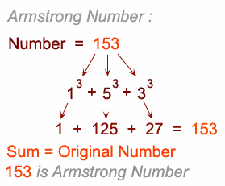

**Question#17**

Write a program that **globaly** declares and assigns 10 integer values in an array and using UDF generates the sum of prime number and return the sum to main() function.

**Question#18**

Using the concept of **Function overloading** make the 4 UDF of same name *solve* which having the following functionality:

1. Solve (First) {Doesn’t return any value but pass the integer value to the UDF and UDF draws its table}.
2. Solve (Second) {Doesn’t return any value but pass the three float values to the UDF and UDF computes the sum of square of these values}.
3. Solve (Third) {Return float value but pass the four integer values to the UDF and UDF computes the average of these values and returns average}.
4. Solve the part (2) using **function template** and same function name but sending 3 integer values (for first UDF execution) and 3 float values (for second UDF execution).

**Question#19**

Write a program which defines a UDF table(). This UDF takes int array of size 5 input from user in its body and prints the table of each number.

**Question#20**

Write a program code for the following given scenario in which multiple UDF calls each other.

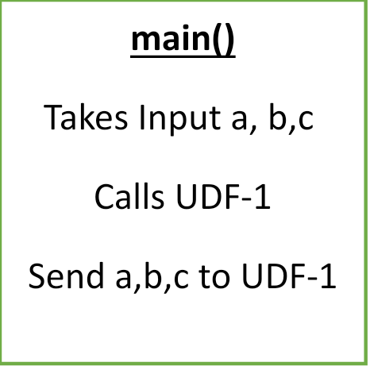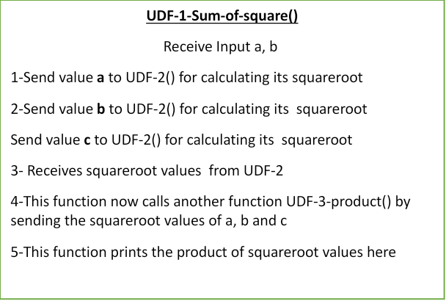



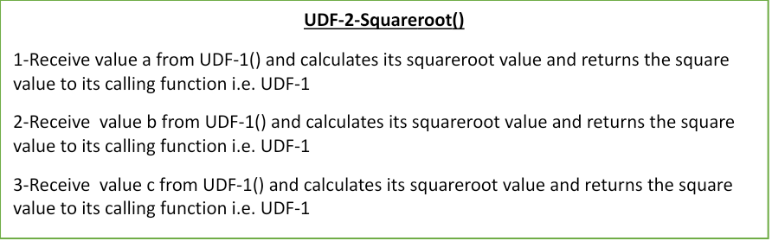

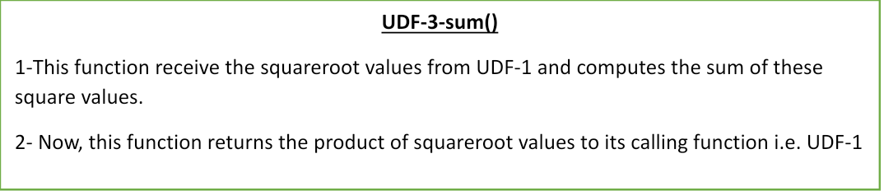

**Question#21**

Write a program using a structure that comprises structure members such as student ID, Student Name, Student GPA, and Student’s 7 marks in an array and we have to initialize the record of two students in two different structure variables. (One is Global and the other one local). Pass this data of two students to a UDF and the UDF prints the data for both students.

**Question #22**

Write a program that takes record of a student input in UDF in structure members as student ID, Student Name, Student GPA, Student percentage and students 5 marks in members of array. The UDF calculates the total of students marks and returns this total to main function and main function prints it.

**Question#23**

Using the C programming, write a code for guessing games with following conditions:

1. First screen shows the instructions about the game.
2. Using the randomize function, computer can thing a number between 1-100.
3. User(s) given 4 choices to guess a number.
4. At each false prediction screen must provide the hint like “ your given number is small or larger”
5. After guessing a number, user must ask whether continue or not.